|  |  |
| --- | --- |
|  | **MINISTRY OF EDUCATION AND TRAINING** |

|  |
| --- |
| **FPT UNIVERSITY** |
| Capstone Project Document |
| World data visualization – Report 04 |
|  |
| |  |  | | --- | --- | | **LKPD group** | | | **Group Members** | Ngo Quang Khanh 00575  Vo Dang Phat 00537  Nguyen Hoang Long 00371  Pham Vu Duc 00491 | | **Supervisor** | Phan Truong Lam | | **Ext Supervisor** |  | | **Capstone Project code** | CP2011_Spr_WDV | |
|  |

|  |
| --- |
| Hanoi, 03/2011 |

Table of Contents

Report 4 – Software design descriptions 5

4.1. System Architectural Design 5

*4.1.1.* *Choice of System Architecture* 5

*4.1.2.* *Discussion of Alternative Designs* 6

*4.1.3.* *Description of System Interface* 7

4.2. Component Diagram 8

4.3. Detailed Description of Components 9

*4.3.1.* *Component-1 : Loader components* 9

*4.3.1.1.* *CRC Cards (Class-Responsibility-Collaborators)* 9

*4.3.1.2.* *Class Diagram* 10

*4.3.1.3.* *Class Diagram Explanation* 10

*4.3.1.4.* *Algorithms of important methods in each class specified in pseudo code or by Flow-Chart* 11

*4.3.2.* *Component-2 : Domain services* 12

*4.3.2.1.* *CRC Cards (Class-Responsibility-Collaborators)* 12

*4.3.2.2.* *Class Diagram* 14

*4.3.2.3.* *Class Diagram Explanation* 14

*4.3.2.4.* *Algorithms of important methods in each class specified in pseudo code or by Flow-Chart* 15

*4.3.2.5.* *Algorithms of important methods in each class specified in pseudo code or by Flow-Chart* 16

*4.3.3.* *Component-3 : Support controls* 17

*4.3.3.1.* *CRC Cards (Class-Responsibility-Collaborators)* 17

*4.3.3.2.* *Class Diagram* 19

*4.3.3.3.* *Class Diagram Explanation* 19

*4.3.3.4.* *Algorithms of important methods in each class specified in pseudo code or by Flow-Chart* 20

*4.3.4.* *Component-4 : Diagram controls* 21

*4.3.4.1.* *CRC Cards (Class-Responsibility-Collaborators)* 21

*4.3.4.2.* *Class Diagram* 23

*4.3.4.3.* *Class Diagram Explanation* 23

*4.3.4.4.* *Algorithms of important methods in each class specified in pseudo code or by Flow-Chart* 24

*4.3.5.* *Component-5 : Helper components* 25

*4.3.5.1.* *CRC Cards (Class-Responsibility-Collaborators)* 25

*4.3.5.2.* *Class Diagram* 25

*4.3.5.3.* *Class Diagram Explanation* 26

*4.3.5.4.* *Algorithms of important methods in each class specified in pseudo code or by Flow-Chart* 27

*4.3.6.* *Component-6 : Data Proxy components* 29

*4.3.6.1.* *CRC Cards (Class-Responsibility-Collaborators)* 29

*4.3.6.2.* *Class Diagram* 32

*4.3.6.3.* *Class Diagram Explanation* 32

*4.3.6.4.* *Algorithms of important methods in each class specified in pseudo code or by Flow-Chart* 33

*4.3.7.* *Component-7: Data mining component* 34

*4.3.7.1.* *CRC Cards (Class-Responsibility-Collaborators)* 34

*4.3.7.2.* *Class Diagram* 36

*4.3.7.3.* *Class Diagram Explanation* 36

*4.3.7.4.* *Algorithms of important methods in each class specified in pseudo code or by Flow-Chart* 37

*4.3.8.* *Component-8: Workspace component* 38

*4.3.8.1.* *CRC Cards (Class-Responsibility-Collaborators)* 38

*4.3.8.2.* *Class Diagram* 40

*4.3.8.3.* *Class Diagram Explanation* 40

*4.3.8.4.* *Algorithms of important methods in each class specified in pseudo code or by Flow-Chart* 41

*4.3.9.* *Component-9 : Authentication component* 42

*4.3.9.1.* *CRC Cards (Class-Responsibility-Collaborators)* 42

*4.3.9.2.* *Class Diagram* 43

*4.3.9.3.* *Class Diagram Explanation* 43

*4.3.9.4.* *Algorithms of important methods in each class specified in pseudo code or by Flow-Chart* 44

4.4. Sequence Diagram 45

*4.4.1.* *Provide data through domain services* 45

*4.4.2.* *Load Silverlight module from xap file* 46

*4.4.3.* *View a country’s statistic graph* 47

*4.4.4.* *View a country’s basic information* 48

*4.4.5.* *Compare statistics between countries* 49

*4.4.6.* *View trade data* 50

*4.4.7.* *Authentication using WindowLiveID* 51

*4.4.8.* *Selecting a country on world map using pushpin* 52

*4.4.9.* *Loading workspace* 53

4.5. User Interface Design 54

*4.5.1.* *Application default interface (initialized interface)* 54

*4.5.1.1.* *Screen Images* 54

*4.5.1.2.* *Objects and Actions* 54

*4.5.2.* *Show a country’s basic information* 54

*4.5.2.1.* *Screen Images* 54

*4.5.2.2.* *Objects and Actions* 55

*4.5.3.* *Showing statistics of a country* 55

*4.5.3.1.* *Screen Images* 55

*4.5.3.2.* *Objects and Actions* 56

*4.5.4.* *Compare statistics between two countries* 56

*4.5.4.1.* *Screen Images* 56

*4.5.4.2.* *Objects and Actions* 57

*4.5.5.* *Change graph type* 57

*4.5.5.1.* *Screen Images* 57

*4.5.5.2.* *Objects and Actions* 58

*4.5.6.* *Show trade data* 58

*4.5.6.1.* *Screen Images* 59

*4.5.6.2.* *Objects and Actions* 60

*4.5.7.* *Log in using window live id* 60

*4.5.7.1.* *Screen Images* 60

*4.5.7.2.* *Objects and Actions* 61

*4.5.8.* *Workspace* 62

*4.5.8.1.* *Screen Images* 62

*4.5.8.2.* *Objects and Actions* 63

4.6. Database Design 64

*4.6.1.* *ERD diagram* 64

*4.6.2.* *Database diagram* 65

*4.6.3.* *Detail database design* 66

*4.6.3.1.* *tbl_country table* 66

*4.6.3.2.* *tbl_indicator table* 66

*4.6.3.3.* *tbl_project table* 67

*4.6.3.4.* *tbl_tab table* 67

*4.6.3.5.* *tbl_trade table* 67

*4.6.3.6.* *tbl_regions table* 68

*4.6.3.7.* *tbl_income_levels table* 68

*4.6.3.8.* *tbl_lending_types table* 68

*4.6.3.9.* *ref_country_indicator table* 69

*4.6.3.10.* *ref_indicator_tab table* 69

4.7. Other material (if any) 70



**Report 4 – Software design descriptions**

* 1. **System Architectural Design**
     1. ***Choice of System Architecture***

- The software architecture we use here is the 3-Tier architecture. This architecture help separate between the presentation tier, the logic tier and the data tier making it easier to maintain the system. For example, when we change the presentation layer, we only have to make minor or no changes to the other layers.

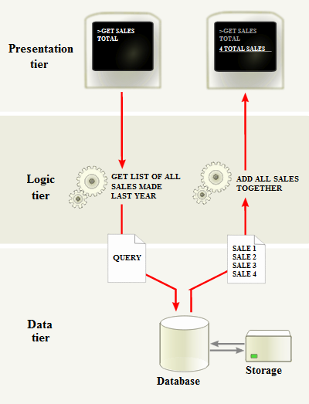

*A diagram showing 3-tier software architecture*

- On another note, even though we use the 3-tier software architecture, we don’t use the 3-tier hardware architecture as commonly recommended because some restriction in budget. Instead, we use 2-tier hardware architecture as the diagram below show:

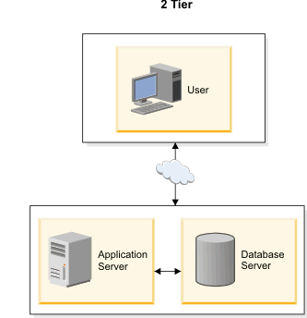

*A diagram showing 2-tier hardware architecture*

* + 1. ***Discussion of Alternative Designs***

- The MVC is a close relative of the 3-tier architecture and is a popular choice among software architects, but the 3-tier architecture’s rule is that the client tier never communicates directly with the data tier. However, the MVC architecture is triangular: the view sends updates to the controller, the controller updates the model, and the view gets updated directly from the model. The diagram of the MVC architecture can be seen below:



*A diagram showing MVC architecture*

* + 1. ***Description of System Interface*** 
       1. *User interfaces*

- User interface should be intuitive and include a world map for graphical selection of regions because the system’s aim is to provide information of all countries in the world, thus selecting by list is too tedious compare to selecting by map.

- User interface should have graphical representations of statistics such as graphs, and if possible, color representation on the map.

* + - 1. *Hardware interfaces*

- The system should be deployed online and available to a wide range of hardware devices. Specifically, the system should be accessible on any computer using Windows© and if possible, other OS as well.

* + - 1. *Software interfaces*

- The system should be able to run on any browser support Silver light © technology and have had Silver light © installed.

- Any service exposed by the system should be accessible using HTTP protocol.

* + - 1. *Communication interfaces*

- Communication between server system and client should be maintained using HTTP protocol or HTTPS protocol for more security if needed be.

- - The communication between client and ID service providers should be in HTTPS for securities reasons.

* 1. **Component Diagram**



* 1. **Detailed Description of Components**
     1. ***Component-1 : Loader components***
        1. *CRC Cards (Class-Responsibility-Collaborators)*

App

- Init point for the Silverlight application

MainPage

MainPage

- The main page to display contents

- Load the silverlight modules to display.

App

LoadSilverlightModuleHelper

LoadSilverlightModuleHelper

- Dynamically Load a “.xap” file which contain silver light modules.

MainPage

* + - 1. *Class Diagram*

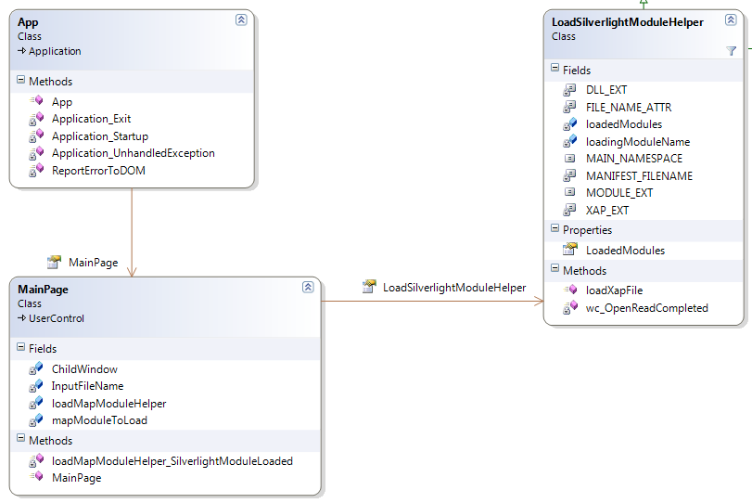

* + - 1. *Class Diagram Explanation*

- The diagram is self-explaining. It’s very easy to understand and there is nothing else to add.

* + - 1. *Algorithms of important methods in each class specified in pseudo code or by Flow-Chart*



* + 1. ***Component-2 : Domain services***
       1. *CRC Cards (Class-Responsibility-Collaborators)*

WBDomainService

- Provide database access to client in the form of web services

ref_country_indicator

ref_tab_indicator

tbl_countries

tbl_income_levels

tbl_indicators

tbl_lending_types

tbl_regions

tbl_tabs

tbl_trades

ref_country_indicator

- An entity represents a table in the system’s database

WBDomainService

tbl_countries

tbl_indicators

ref_tab_indicator

- An entity represents a table in the system’s database

WBDomainService

tbl_tabs

tbl_indicators

tbl_countries

- An entity represents a table in the system’s database

WBDomainService

tbl_indicators

tbl_income_levels

tbl_lending_types

tbl_regions

tbl_trades

tbl_income_levels

- An entity represents a table in the system’s database

WBDomainService

tbl_countries

tbl_indicators

- An entity represents a table in the system’s database

WBDomainService

tbl_countries

tbl_tabs

tbl_lending_types

- An entity represents a table in the system’s database

WBDomainService

tbl_countries

tbl_regions

- An entity represents a table in the system’s database

WBDomainService

tbl_countries

tbl_tabs

- An entity represents a table in the system’s database

WBDomainService

tbl_countries

tbl_trades

- An entity represents a table in the system’s database

WBDomainService

tbl_countries

* + - 1. *Class Diagram*

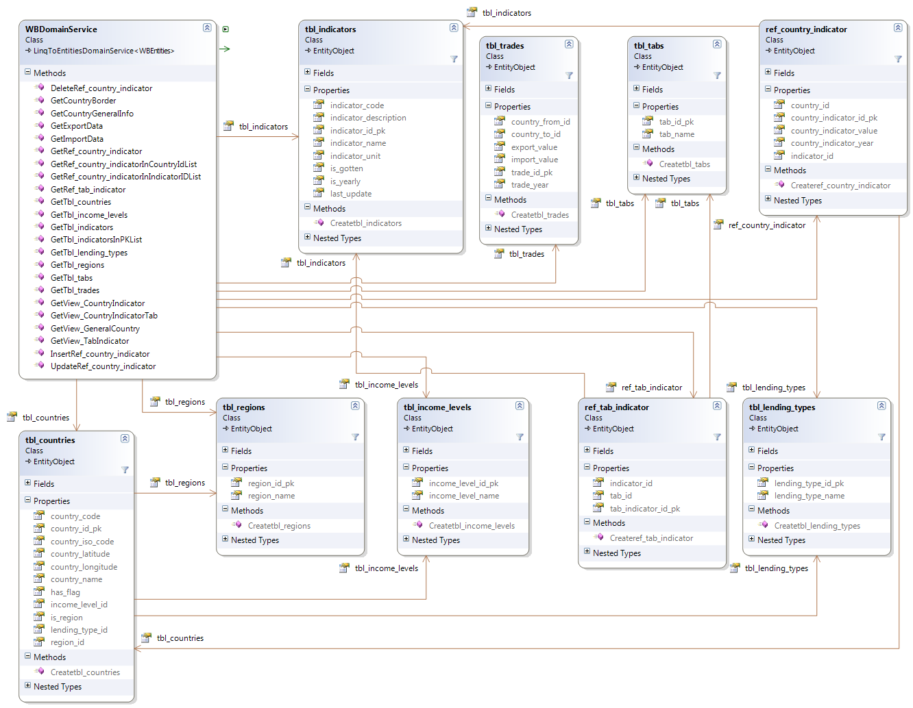

* + - 1. *Class Diagram Explanation*

- The diagram is self-explaining. It’s very easy to understand and there is nothing else to add.

* + - 1. *Algorithms of important methods in each class specified in pseudo code or by Flow-Chart*



* + - 1. *Algorithms of important methods in each class specified in pseudo code or by Flow-Chart*
    1. ***Component-3 : Support controls***
       1. *CRC Cards (Class-Responsibility-Collaborators)*

MainPage

- Show the main GUI.

- Display the support GUI.

About

CompareCountriesChildWindow

CustomChildWindow

DraggablePushpin

ErrorNotification

TradeMode

About

- Show the about dialog on main interface of the system

MainPage

CompareCountriesChildWindow

- The dialog showing comparison statistics between countries

MainPage

CustomChildWindow

- Showing basic information of a country

- Showing statistics of a country

MainPage

DraggablePushpin

- Select a country on the world map

Trigger for showing country statistics

MainPage

ErrorNotification

- Display all kinds of error notification to user

MainPage

TradeMode

- Showing arrows on the world map

- Showing statistics of countries on trading

MainPage

* + - 1. *Class Diagram*

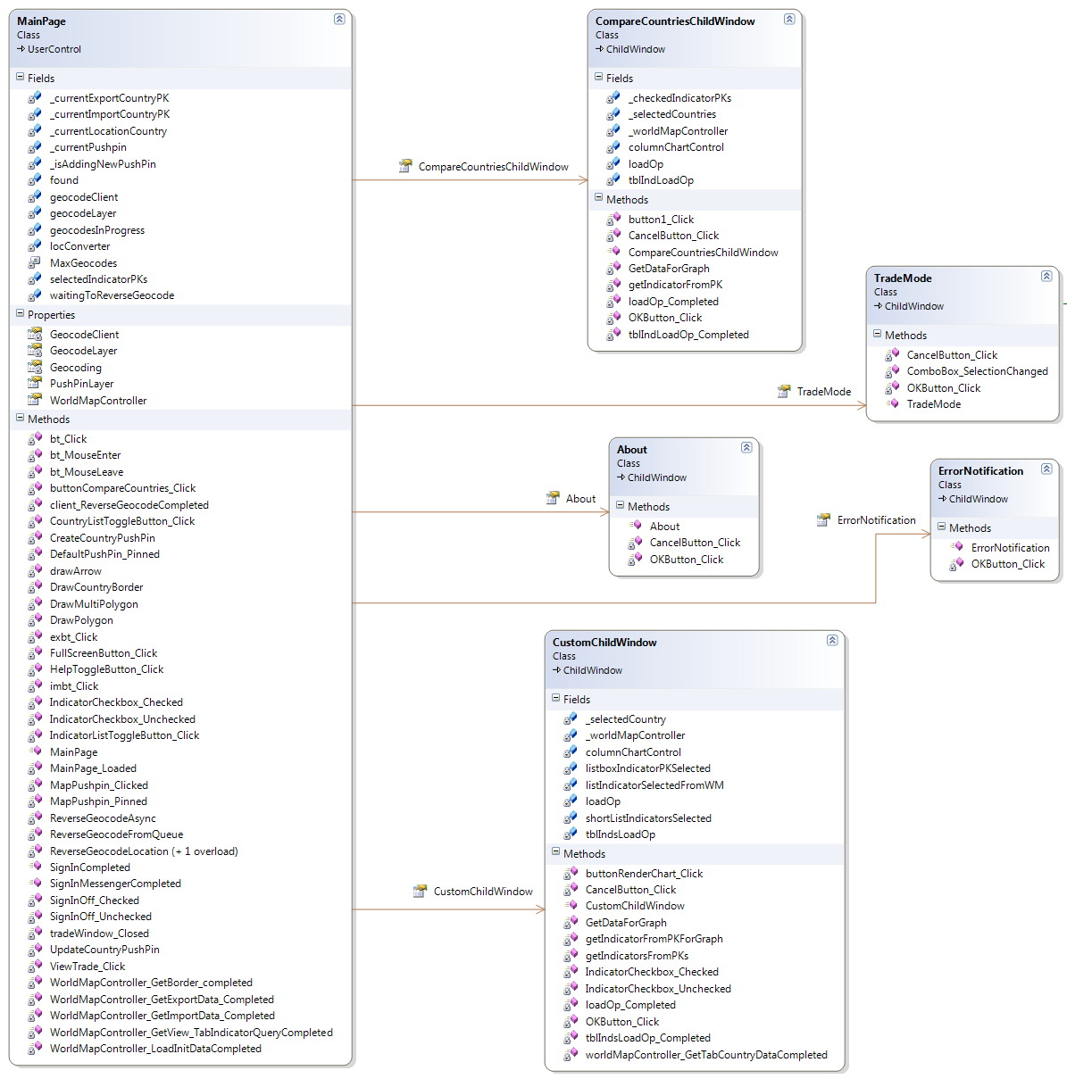

* + - 1. *Class Diagram Explanation*

- The diagram is self-explaining. It’s very easy to understand and there is nothing else to add.

* + - 1. *Algorithms of important methods in each class specified in pseudo code or by Flow-Chart*



* + 1. ***Component-4 : Diagram controls***
       1. *CRC Cards (Class-Responsibility-Collaborators)*

WorldbankGeneralChartControl

- Generate various kind of chart based on input

Constants

ChartUtils

DummyDataGenerator

Country

YearData

WorldbankPieChartControl

- Generate pie chart

Constants

ChartUtils

DummyDataGenerator

PieSlice

DummyDataGenerator

- Generate dummy data to test charts when no real data is available.

WorldbankGeneralChartControl

WorldbankPieChartControl

PieSlice

Country

YearData

Constants

- Contain constants.

WorldbankGeneralChartControl

WorldbankPieChartControl

ChartUtils

- Contain common functions for the charts

WorldbankGeneralChartControl

WorldbankPieChartControl

Country

- Contain data about a country

WorldbankGeneralChartControl

DummyDataGenerator

YearData

- Contain data of a certain year for a country

WorldbankGeneralChartControl

Country

DummyDataGenerator

PieSlice

- Contain data for a slice of pie chart graph

WorldbankPieChartControl

DummyDataGenerator

* + - 1. *Class Diagram*

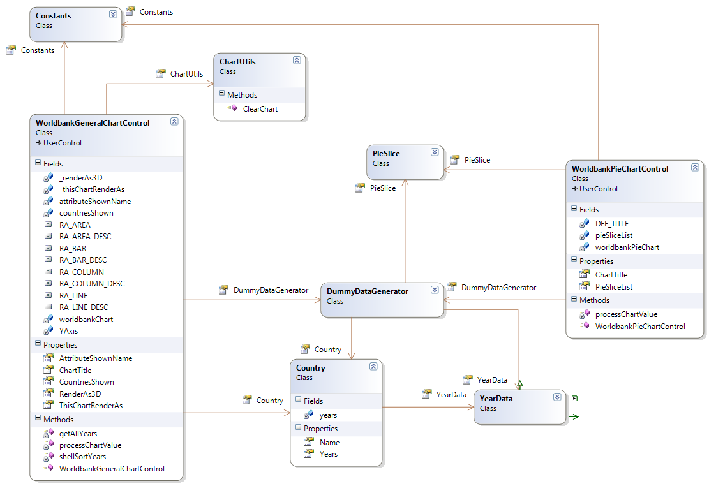

* + - 1. *Class Diagram Explanation*

- The diagram is self-explaining. It’s very easy to understand and there is nothing else to add.

* + - 1. *Algorithms of important methods in each class specified in pseudo code or by Flow-Chart*



* + 1. ***Component-5 : Helper components***
       1. *CRC Cards (Class-Responsibility-Collaborators)*

MainPage

- Show the main GUI

- Call helper classes

[Collaborators]

Controller

Act as the controller to access Domain Services from server to get data.

MainPage

FullScreenCommand

Help control the full screen application of the system on client’s side

MainPage

WKTToGeomatryPoint

Translate from WKT format to Geometry points on the world map.

MainPage

* + - 1. *Class Diagram*

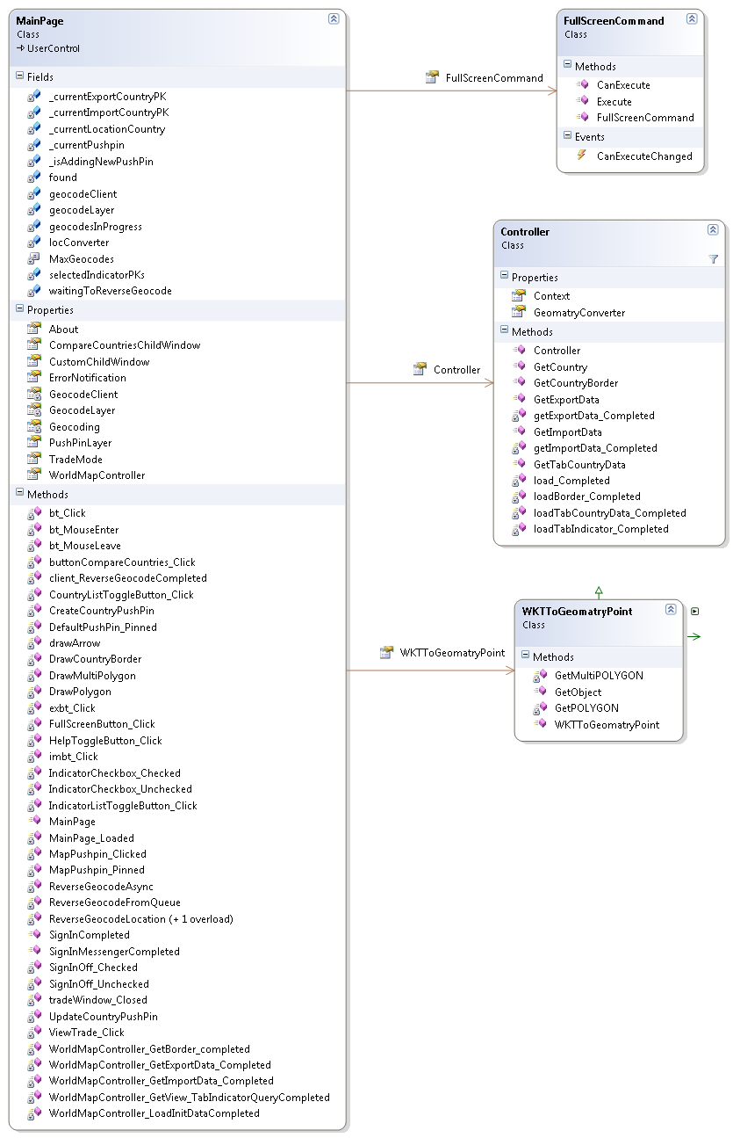

* + - 1. *Class Diagram Explanation*

- The diagram is self-explaining. It’s very easy to understand and there is nothing else to add.

* + - 1. *Algorithms of important methods in each class specified in pseudo code or by Flow-Chart*



*Flow chart 1 – Full screen helper*



*Flow chart 2 – Controller control data communication with server*

* + 1. ***Component-6 : Data Proxy components***
       1. *CRC Cards (Class-Responsibility-Collaborators)*

WebContext

Connect the proxy WBDomainContext class and all proxy class with the domain service on server

WBDomainContext

WBDomainContext

The proxy for the domain service at client side

WBDomainContext

ref_country_indicator

ref_tab_indicator

tbl_countries

tbl_income_levels

tbl_indicators

tbl_lending_types

tbl_regions

tbl_tabs

tbl_trades

ref_country_indicator

- An entity represents a table in the system’s database

WBDomainContext

tbl_countries

tbl_indicators

ref_tab_indicator

- An entity represents a table in the system’s database

WBDomainContext

tbl_tabs

tbl_indicators

tbl_countries

- An entity represents a table in the system’s database

WBDomainContext

tbl_indicators

tbl_income_levels

tbl_lending_types

tbl_regions

tbl_trades

tbl_income_levels

- An entity represents a table in the system’s database

WBDomainContext

tbl_countries

tbl_indicators

- An entity represents a table in the system’s database

WBDomainContext

tbl_countries

tbl_tabs

tbl_lending_types

- An entity represents a table in the system’s database

WBDomainContext

tbl_countries

tbl_regions

- An entity represents a table in the system’s database

WBDomainContext

tbl_countries

tbl_tabs

- An entity represents a table in the system’s database

WBDomainContext

tbl_countries

tbl_trades

- An entity represents a table in the system’s database

WBDomainContext

tbl_countries

* + - 1. *Class Diagram*

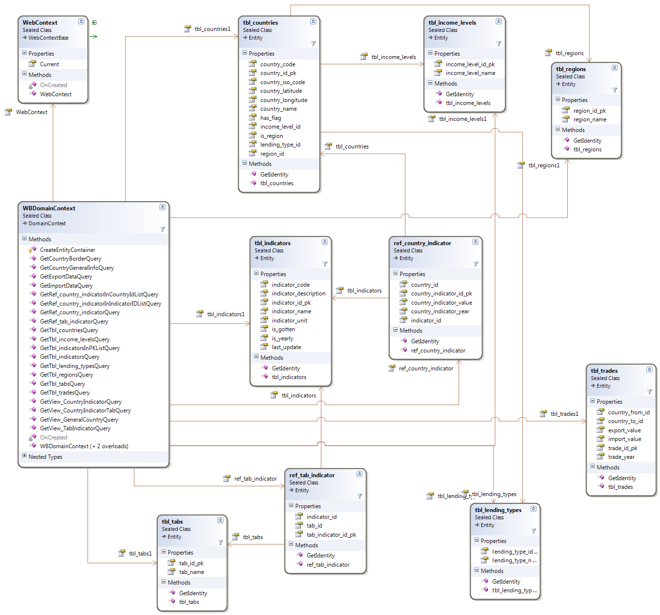

* + - 1. *Class Diagram Explanation*

- The diagram is self-explaining. It’s very easy to understand and there is nothing else to add.

* + - 1. *Algorithms of important methods in each class specified in pseudo code or by Flow-Chart*



* + 1. ***Component-7: Data mining component***
       1. *CRC Cards (Class-Responsibility-Collaborators)*

Main Controller

Call the suitable crawlers to get data and save data into Database using DBAccess

* Crawler
* DBAccess
* Trade analyzer

Crawler

Get data from data source using ProjectCrawler, WBCrawler and UtilCrawler

* Data source
* Main controller
* DBAccess
* ProjectCrawler
* WBCrawler
* UtilCrawler

ProjectCrawler

Html tag analyzing and searching for suitable data

* DBAccess
* ProjectEntry
* CountryEntry
* Crawler

WBCrawler

Get data from worldbank using worldbank api

* Main controller
* DBAccess
* Crawler
* ProjectEntry
* IndicatorEntry
* IncomelevelEntry
* LendingTypeEntry
* CountryEntry
* TradeEntry

UtilCrawler

* Main controller
* DBAccess
* ProjectCrawler
* UtilCrawler
* WbCrawler

TradeAnalyzer

Read data from excel (tradata) and integrated them with Worldbank Data

* Main Controller
* ProjectEntry
* CountryEntry
* DBAccess

DBAccess

Save data to database

* Main controller
* Crawler
* Trade Analyzer
* ProjectEntry
* IndicatorEntry
* IncomelevelEntry
* LendingTypeEntry
* CountryEntry
* TradeEntry
  + - 1. *Class Diagram*

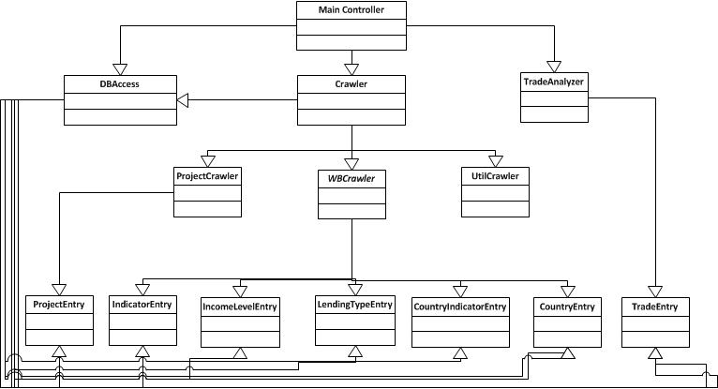

* + - 1. *Class Diagram Explanation*

- The diagram is self-explaining. It’s very easy to understand and there is nothing else to add.

* + - 1. *Algorithms of important methods in each class specified in pseudo code or by Flow-Chart*

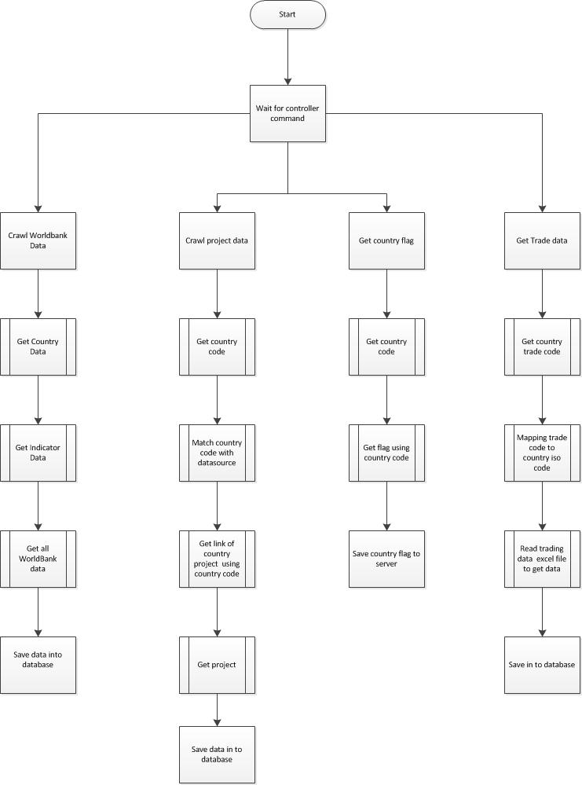

* + 1. ***Component-8: Workspace component***
       1. *CRC Cards (Class-Responsibility-Collaborators)*

MainPage

Showing the gui and the workspace

Workspace

Workspace

Showing the interface of the workspace and all customizable aspects of it to users

WBDomainControl

WBDomainContext

Context of the DomainService to provide data to client

WebContext

tbl_users

ref_user_country

ref_user_indicator_graph

ref_user_tab

View_user_Country

WebContext

Connect to server services using web service interface

WBDomainContext

ref_user_country

Representing the table of the same name in database

WBDomainContext

ref_user_indicator_graph

Representing the table of the same name in database

WBDomainContext

ref_user_tab

Representing the table of the same name in database

WBDomainContext

View_user_Country

Representing the table of the same name in database

WBDomainContext

* + - 1. *Class Diagram*

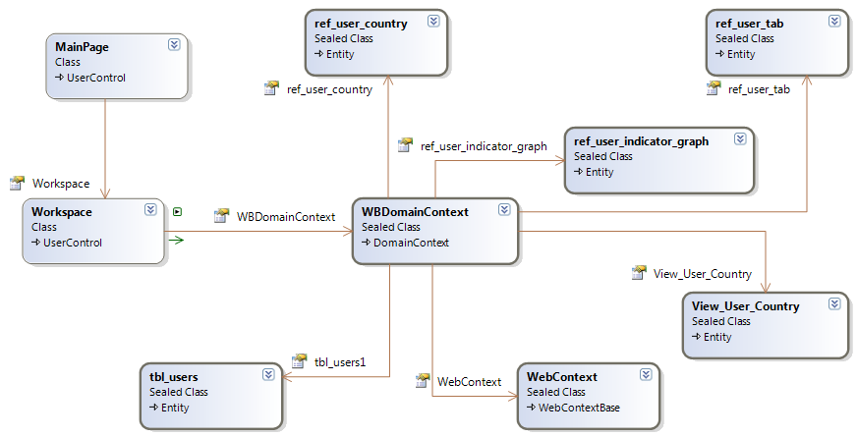

* + - 1. *Class Diagram Explanation*

- The diagram is self-explaining. It’s very easy to understand and there is nothing else to add.

* + - 1. *Algorithms of important methods in each class specified in pseudo code or by Flow-Chart*



* + 1. ***Component-9 : Authentication component***
       1. *CRC Cards (Class-Responsibility-Collaborators)*

MainPage

- Communicate with Helpers to authenticate users.

- Display data onto main GUI

FacebookAuthenticationHelper

TwitterAuthenticationHelper

WindowLiveIDAuthenticationHelper

FacebookAuthenticationHelper

- Communicate with Facebook authentication provider

- Receive data from server and relay it to the main page

Mainpage

TwitterAuthenticationHelper

- Communicate with Twitter authentication provider

- Receive data from server and relay it to the main page

Mainpage

WindowLiveIDAuthenticationHelper

- Communicate with Window Live ID authentication provider

- Receive data from server and relay it to the main page

Mainpage

* + - 1. *Class Diagram*

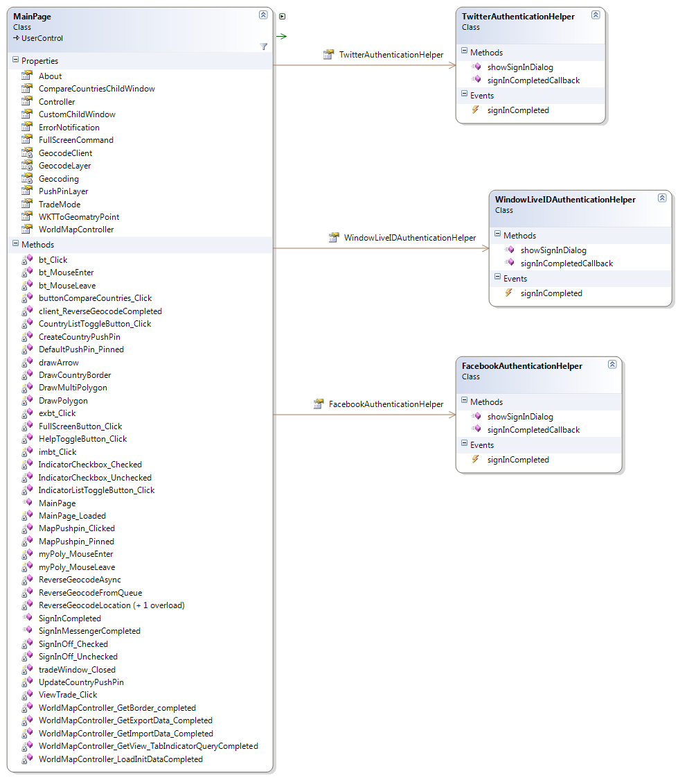

* + - 1. *Class Diagram Explanation*

- The diagram is self-explaining. It’s very easy to understand and there is nothing else to add.

* + - 1. *Algorithms of important methods in each class specified in pseudo code or by Flow-Chart*



* 1. **Sequence Diagram**
     1. ***Provide data through domain services***



* + 1. ***Load Silverlight module from xap file***



* + 1. ***View a country’s statistic graph***



* + 1. ***View a country’s basic information***



* + 1. ***Compare statistics between countries***



* + 1. ***View trade data***



* + 1. ***Authentication using WindowLiveID***



* + 1. ***Selecting a country on world map using pushpin***



* + 1. ***Loading workspace***



* 1. **User Interface Design**
     1. ***Application default interface (initialized interface)***
        1. *Screen Images*

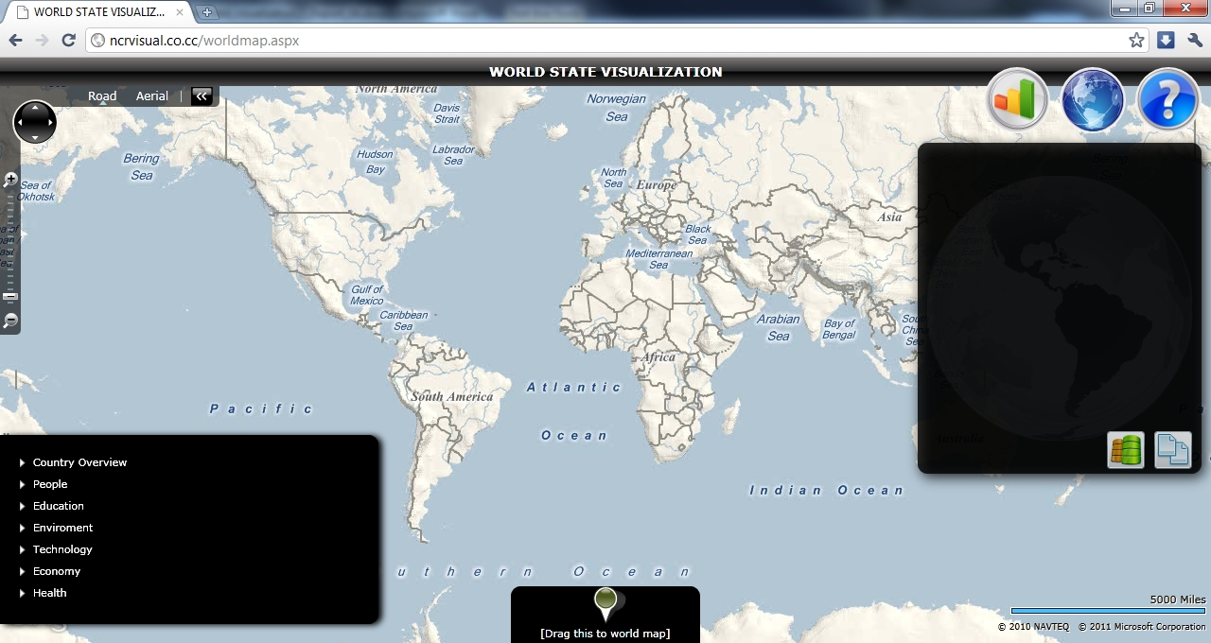

* + - 1. *Objects and Actions*

N/A

* + 1. ***Show a country’s basic information***
       1. *Screen Images*

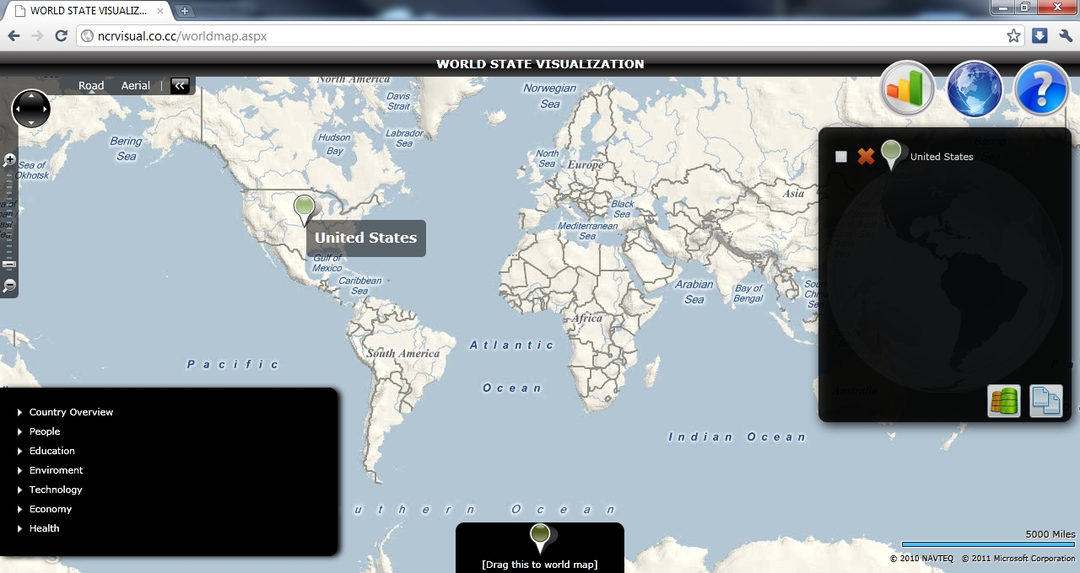

*Screen 01 – Select a country by dragging a pin onto it*

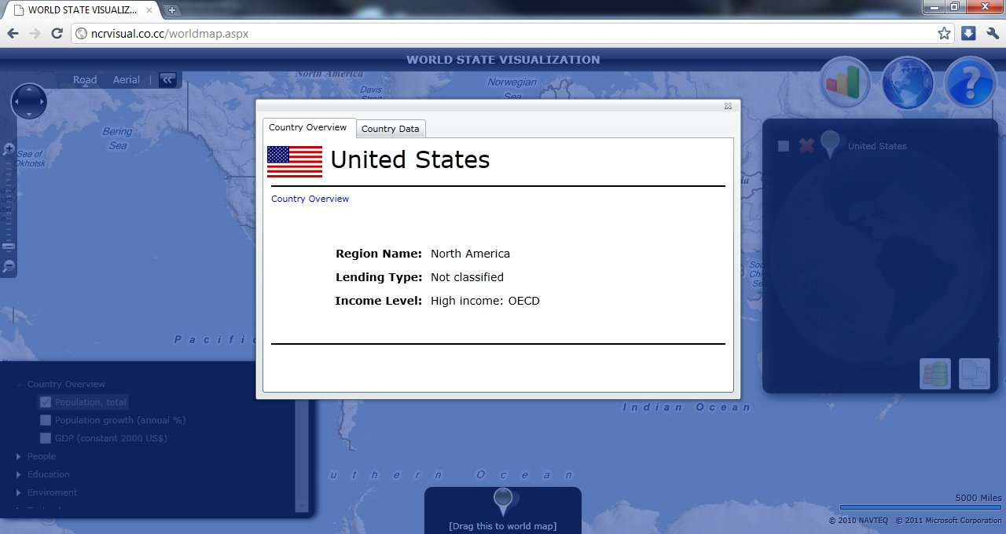

*Screen 02 – Showing basic information of a country*

* + - 1. *Objects and Actions*

Objects: Draggable Pin, Country overview popup dialog.

Action: Drag the pin onto the world map, left-click on the pin.

* + 1. ***Showing statistics of a country***
       1. *Screen Images*



*Screen 01 – Select a country on world map*

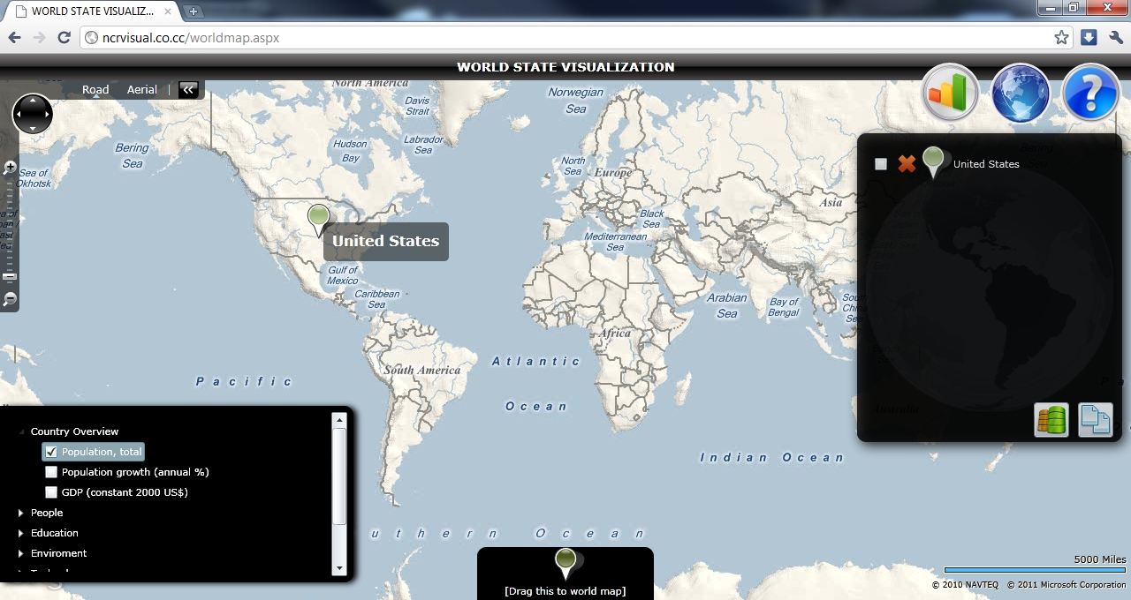

*Screen 02 – Select an indicator from indicator list*

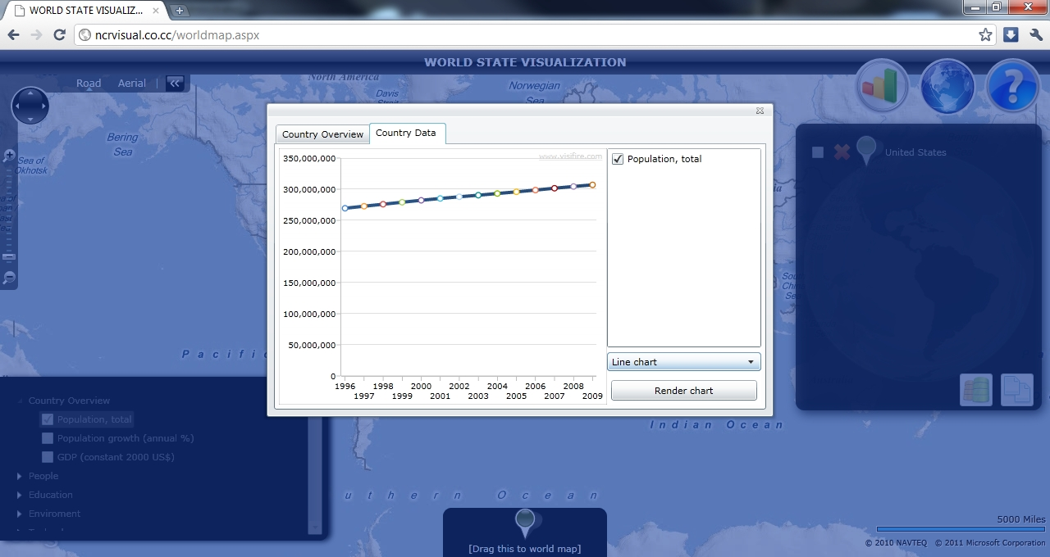

*Screen 03 – Show selected statistics of selected country*

* + - 1. *Objects and Actions*

Objects: Draggable Pin, indicators list, Country overview popup dialog.

Action: Drag the pin onto the world map, select indicator, left-click on the pin, change to country data tab.

* + 1. ***Compare statistics between two countries***
       1. *Screen Images*

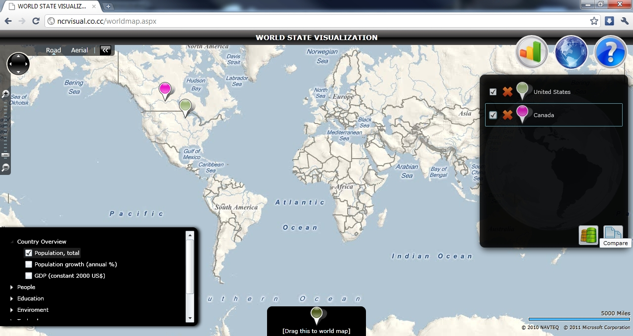

*Screen 01 – Select multiple countries on map and on shortlist, select indicators*

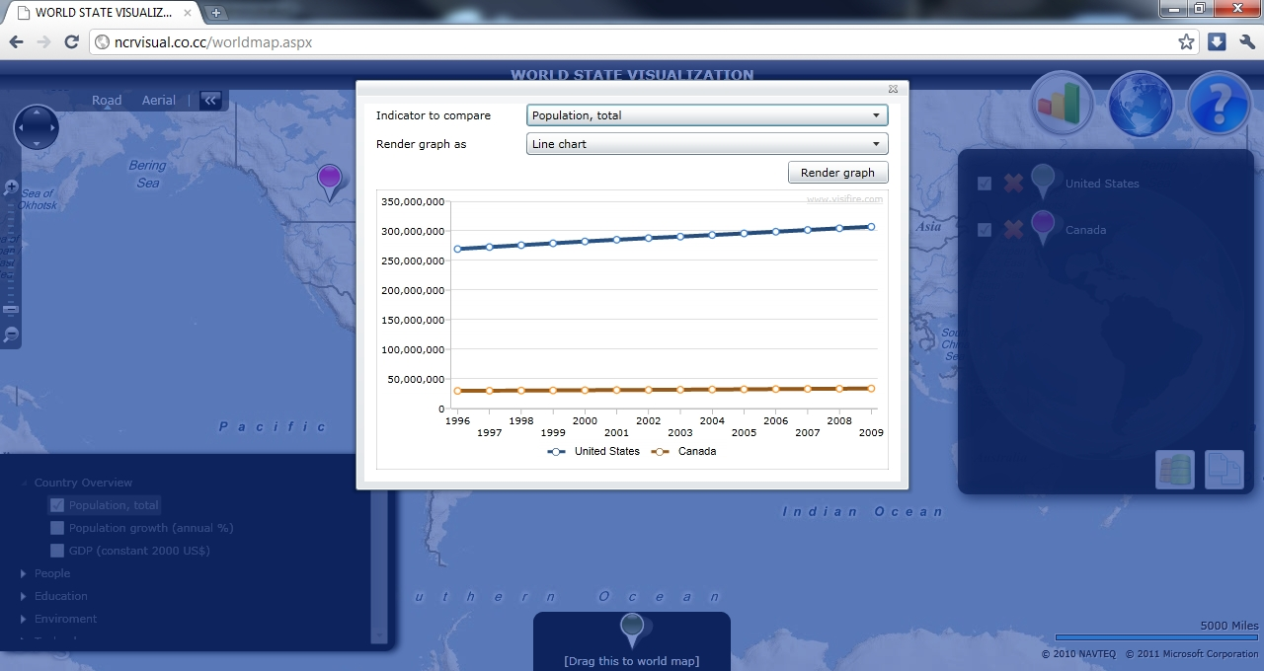

*Screen 02 – Comparison dialog showing the comparison of statistics on selected countries*

* + - 1. *Objects and Actions*

Objects: Draggable Pin, indicators list, country shortlist, Statistics comparison popup dialog.

Action: Drag the pin onto the world map, select indicator, and click on “Compare data” button.

* + 1. ***Change graph type***
       1. *Screen Images*

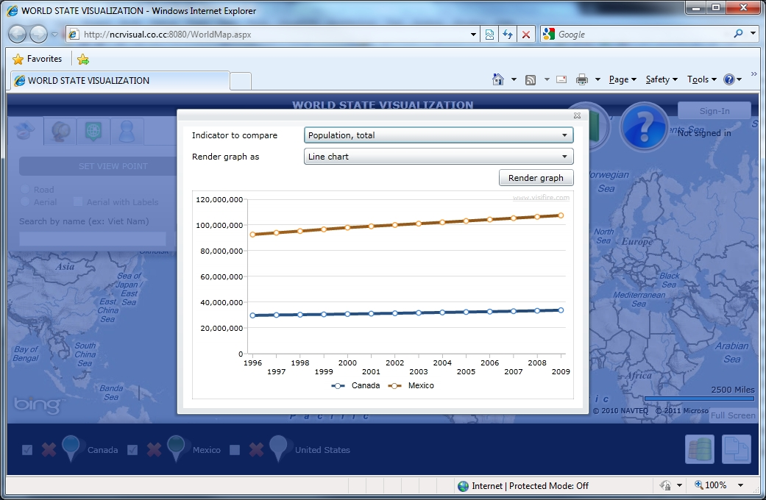

*Screen 01 – Default graph type*

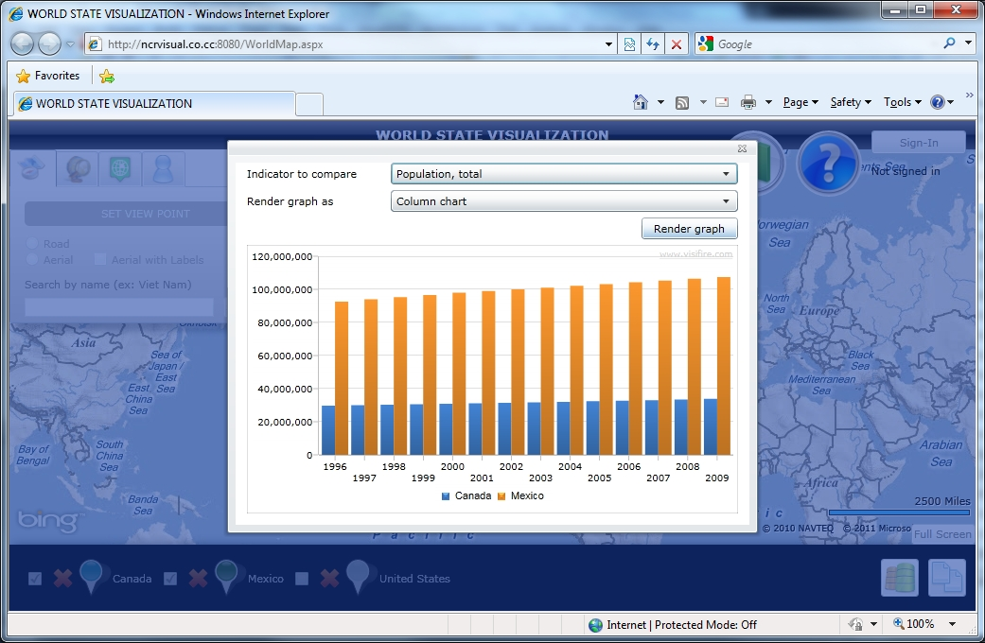

*Screen 02 – After changing the graph type and re-render the graph*

* + - 1. *Objects and Actions*

Objects: Graph dialog, Graph type combobox, render button

Action: Click compare or show graph of a country, change graph type, click on render button to re-render the graph.

* + 1. ***Show trade data***
       1. *Screen Images*

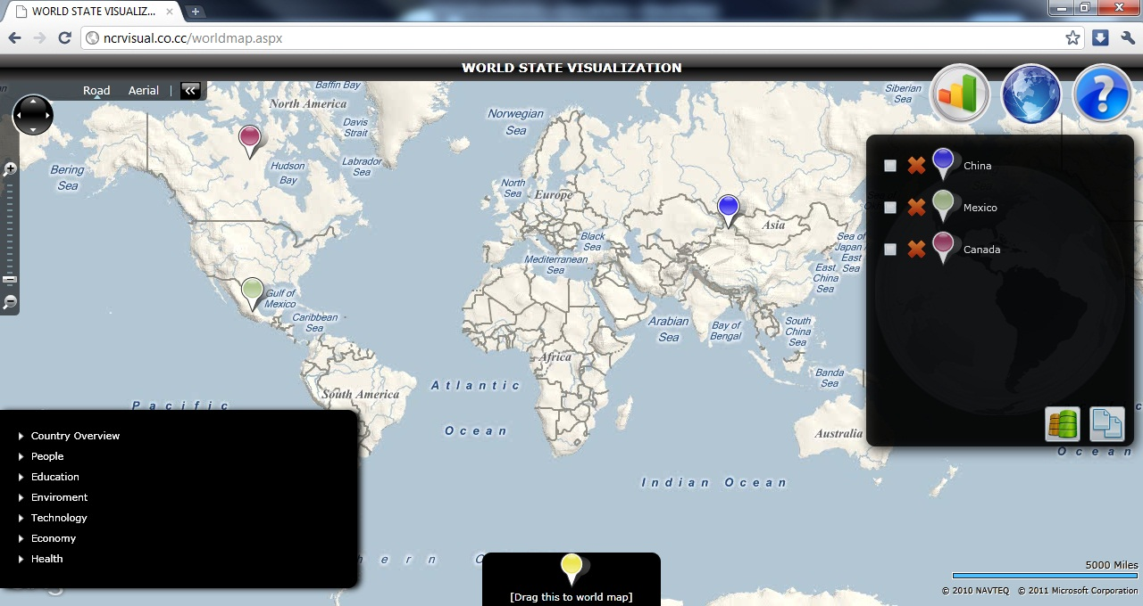

*Screen 01 – Select multiple countries*

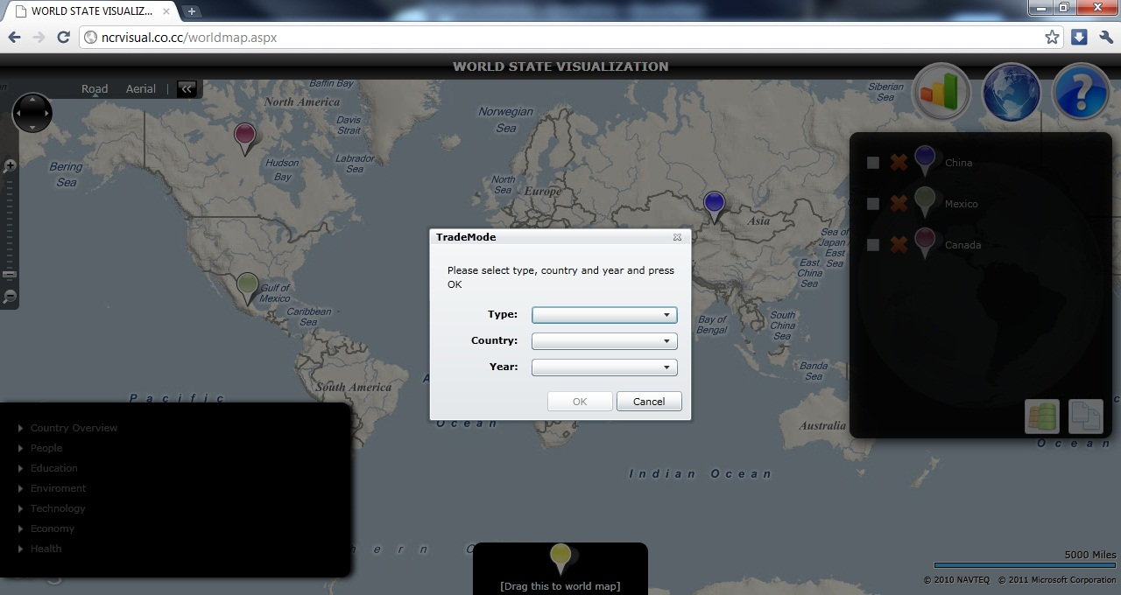

*Screen 02 – Click “Trade data” button, TradeMode dialog shown*

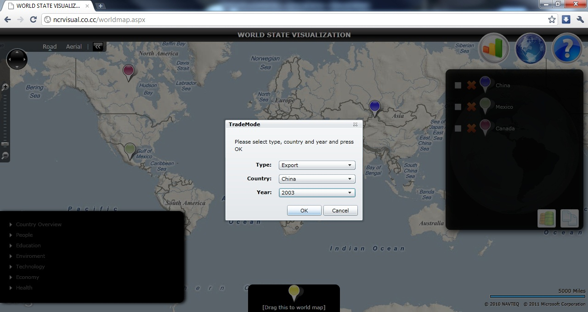

*Screen 03 – Select appropriate option from the dialog and click “OK”*

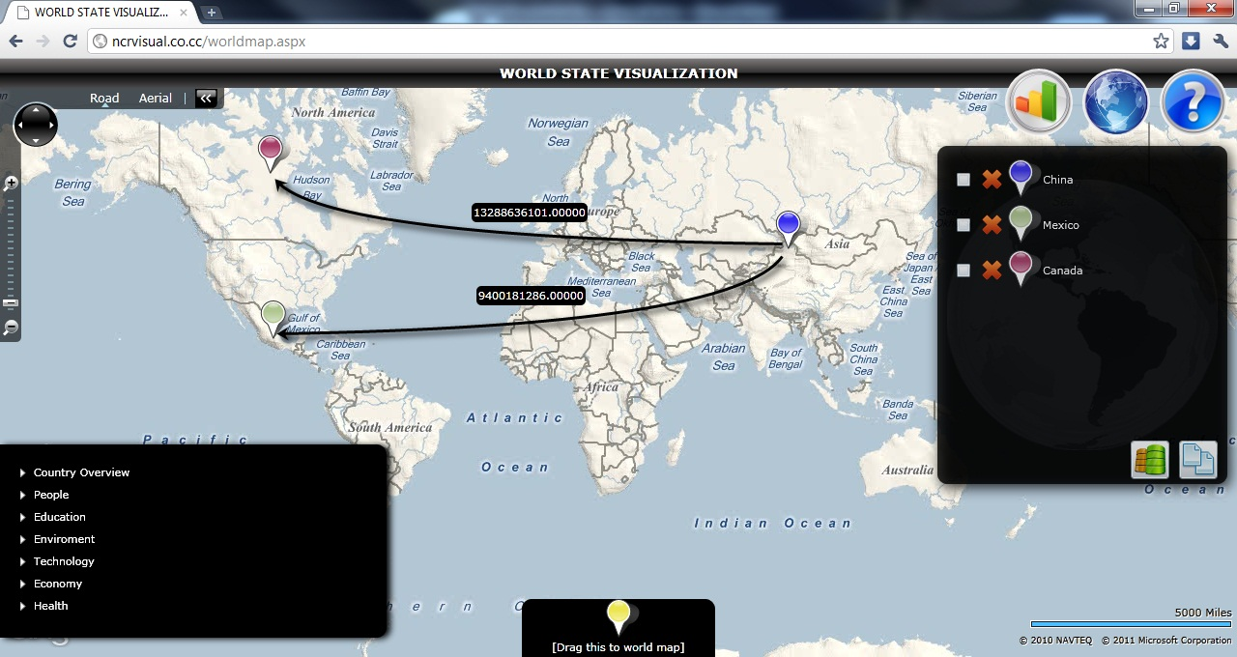

*Screen 04 – Trade data between selected countries are shown*

* + - 1. *Objects and Actions*

Objects: Draggable Pin, country shortlist, TradeMode popup, TradeData arrows.

Action: Drag the pin onto the world map, click on “Trade Data” button, select options, show trade Data.

* + 1. ***Log in using window live id***
       1. *Screen Images*

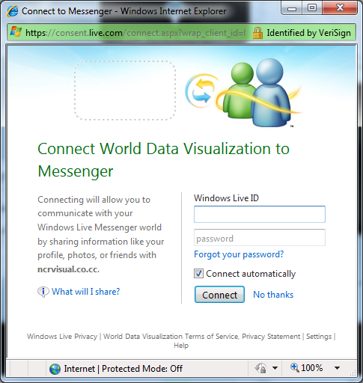

*Screen 01 – Sign in popup*

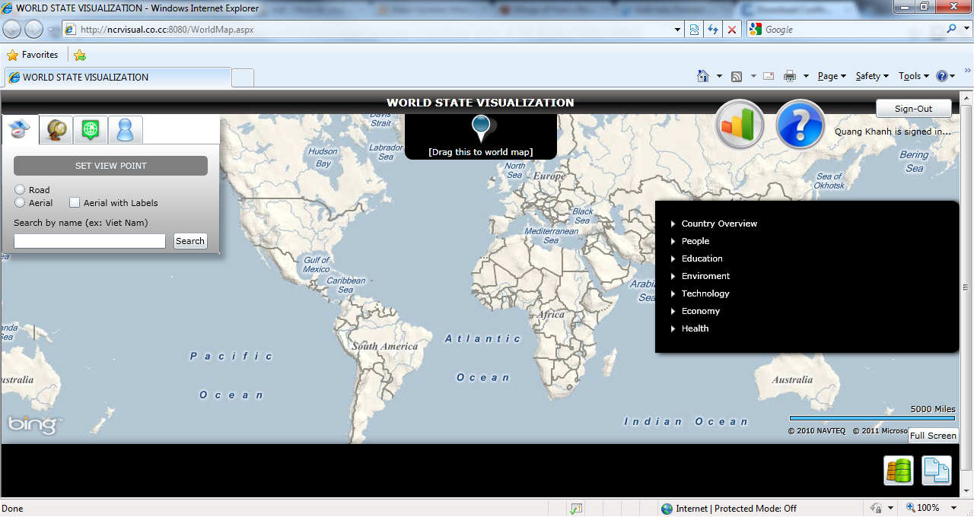

*Screen 02 – Sign in completed successfully*

* + - 1. *Objects and Actions*

Objects: SignInOut toggle button, login dialog..

Action: Click the login button, type username and password into login dialog, click login, click logout.

* + 1. ***Workspace***
       1. *Screen Images*

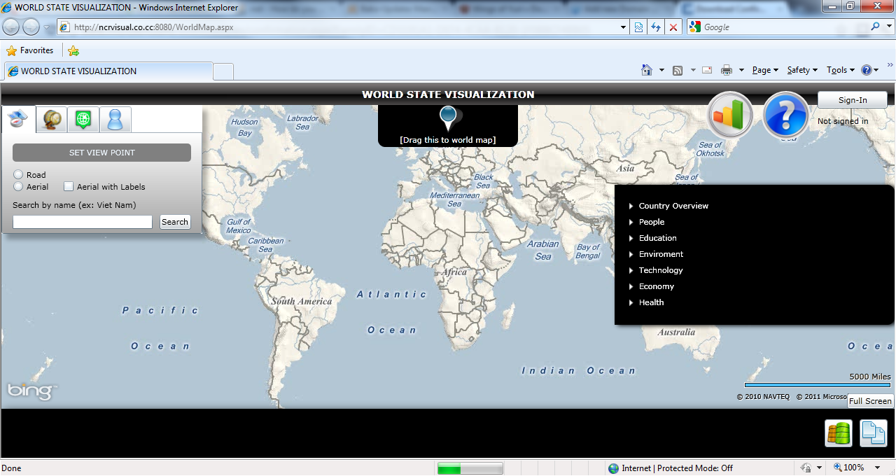

*Screen 01 – Workspace customize panel on the upper left of the screen*

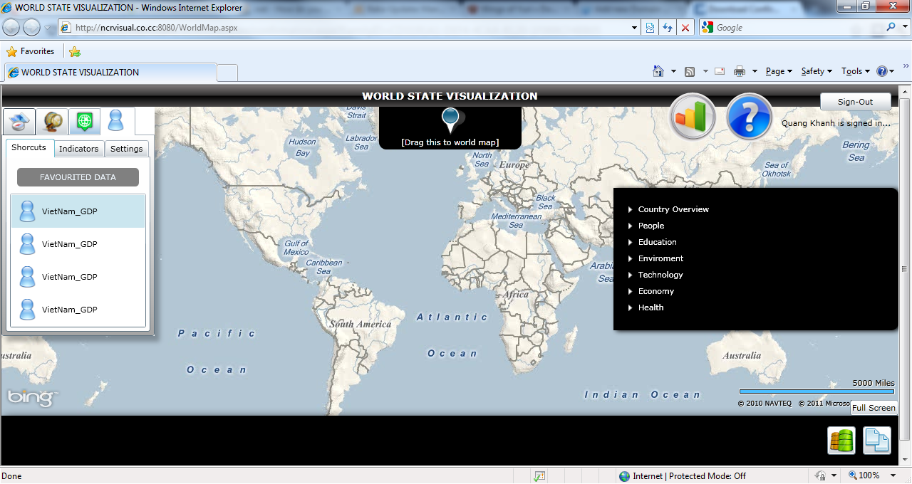

*Screen 02 – Personal customization, shortcut part*

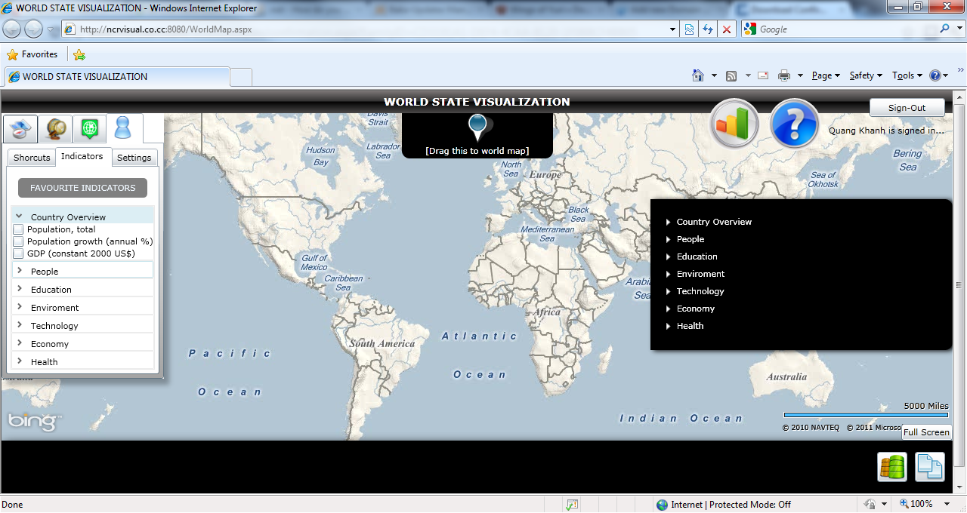

*Screen 03 – Customize favorite indicator*

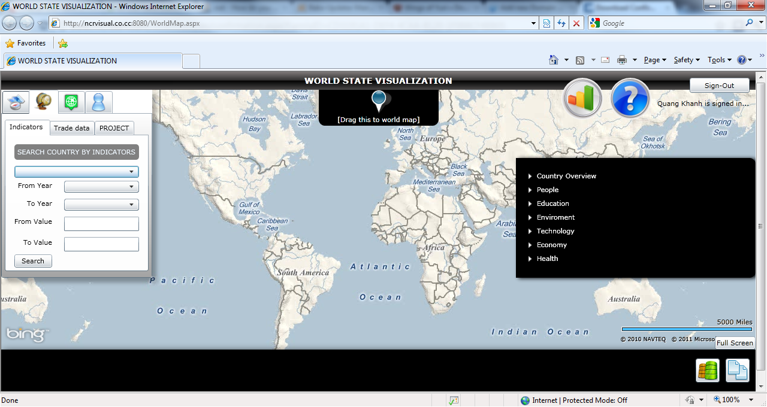

*Screen 04 - Search country*

* + - 1. *Objects and Actions*

Objects: SignInOut toggle button, workspace customize panel.

Action: Click the login button, type username and password into login dialog, click login, customize the workspace control panel.

* 1. **Database Design**
     1. ***ERD diagram***

Region

Belong to

Have

Belong to

Country

Income level

Of

Tab

Indicator

Have

Workspace

Have

User

* + 1. ***Database diagram***

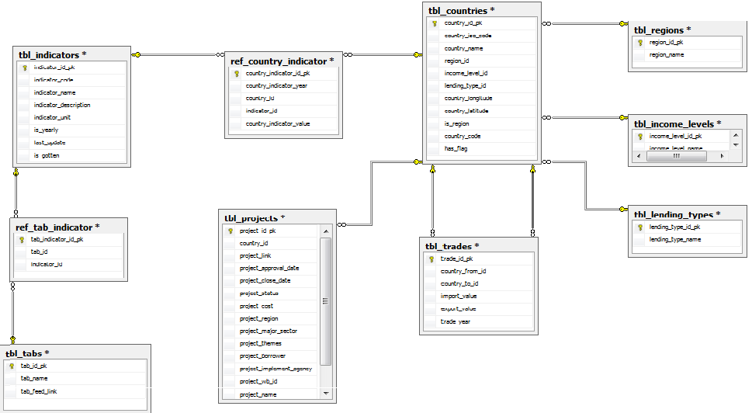

* + 1. ***Detail database design***
       1. *tbl_country table*

|  |  |  |  |  |  |  |  |  |
| --- | --- | --- | --- | --- | --- | --- | --- | --- |
| No | Field Name | Type | Length | Null | Unique | P/F Key | Default | Description |
| 01 | Country_id_pk | INT | N/A |  | X | P | Auto increase | ID number of student |
| 02 | Country_iso_code | VARCHAR | 255 |  |  |  |  | Name of student |
| 03 | Country_name | VARCHAR | 255 |  |  |  |  | Birthday of student |
| 04 | Regionid | INT | 11 |  |  | F |  | ID of the class this student is in |
| 05 | Income_level_id | INT | 11 |  |  | F |  |  |
| 06 | Lending_type_id | INT | 11 |  |  | F |  |  |
| 07 | Country_longtitude | DOUBLE |  |  |  |  |  |  |
| 08 | Country_latitude | DOUBLE |  |  |  |  |  |  |
| 09 | Is_region | BOOL |  |  |  |  |  |  |
| 10 | Country_code | VAR_CHAR | 255 |  |  |  |  |  |
| 11 | Has_flag | BOOL |  |  |  |  |  |  |

* + - 1. *tbl_indicator table*

|  |  |  |  |  |  |  |  |  |
| --- | --- | --- | --- | --- | --- | --- | --- | --- |
| No | Field Name | Type | Length | Null | Unique | P/F Key | Default | Description |
| 01 | Indicator_id_pk | INT | 11 |  | X | P | Auto increase |  |
| 02 | Indicator_code | VARCHAR | 50 |  |  |  |  |  |
| 03 | Indicator_name | VARCHAR | 255 |  |  |  |  |  |
| 04 | Indicator_description | VARCHAR | 255 |  |  |  |  |  |
| 05 | Indicator_unit | VARCHAR | 255 |  |  |  |  |  |
| 06 | Is_yearly | BOOL |  |  |  |  |  |  |
| 07 | Last_update | DATETIME | N/A |  |  |  |  |  |
| 08 | Is_gotten | BOOL |  |  |  |  |  |  |

* + - 1. *tbl_project table*

|  |  |  |  |  |  |  |  |  |
| --- | --- | --- | --- | --- | --- | --- | --- | --- |
| No | Field Name | Type | Length | Null | Unique | P/F Key | Default | Description |
| 01 | Project_id_pk | INT | 11 |  | X | P | Auto increase |  |
| 02 | Country_id | INT | 11 |  |  | F |  |  |
| 03 | Project_link | VARCHAR | 255 |  |  |  |  |  |
| 04 | Project_approval_date | DATETIME | N/A |  |  |  |  |  |
| 05 | Project_close_date | DATETIME | N/A |  |  |  |  |  |
| 06 | Project_status | INT | 4 |  |  |  |  |  |
| 07 | Project_cost | DOUBLE | N/A |  |  |  |  |  |
| 08 | Project_region | VARCHAR | 255 |  |  |  |  |  |
| 09 | Project_major_sector | VARCHAR | 255 |  |  |  |  |  |
| 10 | Project_themes | VARCHAR | 255 |  |  |  |  |  |
| 11 | Project_borrower | VARCHAR | 255 |  |  |  |  |  |
| 12 | Project_agency | VARCHAR | 255 |  |  |  |  |  |
| 13 | Project_wb_id | VARCHAR | 255 |  |  |  |  |  |
| 14 | Project_name | VARCHAR | 255 |  |  |  |  |  |

* + - 1. *tbl_tab table*

|  |  |  |  |  |  |  |  |  |
| --- | --- | --- | --- | --- | --- | --- | --- | --- |
| No | Field Name | Type | Length | Null | Unique | P/F Key | Default | Description |
| 01 | Tab_id_pk | INT | 11 |  | X | P | Auto increase |  |
| 02 | Tab_name | VARCHAR | 255 |  |  |  |  |  |
| 03 | Tab_feed_link | VARCHAR | 255 |  |  |  |  |  |

* + - 1. *tbl_trade table*

|  |  |  |  |  |  |  |  |  |
| --- | --- | --- | --- | --- | --- | --- | --- | --- |
| No | Field Name | Type | Length | Null | Unique | P/F Key | Default | Description |
| 01 | Trade_id_pk | INT | 11 |  | X | P | Auto increase |  |
| 02 | Country_from_id | VARCHAR | 11 |  |  | F |  |  |
| 03 | Country_to_id | DATETIME | 11 |  |  | F |  |  |
| 04 | Import_value | Decimal | (18,5) |  |  |  |  |  |
| 05 | Export_value |  | (18,5) |  |  |  |  |  |
| 06 | Trade_year |  | 11 |  |  |  |  |  |

* + - 1. *tbl_regions table*

|  |  |  |  |  |  |  |  |  |
| --- | --- | --- | --- | --- | --- | --- | --- | --- |
| No | Field Name | Type | Length | Null | Unique | P/F Key | Default | Description |
| 01 | Region_id_pk | INT | N/A |  | X | P | Auto increase | ID number of student |
| 02 | Region_name | VARCHAR | 255 |  |  |  |  | Name of student |

* + - 1. *tbl_income_levels table*

|  |  |  |  |  |  |  |  |  |
| --- | --- | --- | --- | --- | --- | --- | --- | --- |
| No | Field Name | Type | Length | Null | Unique | P/F Key | Default | Description |
| 01 | Incom_level_id_pk | INT | 11 |  | X | P | Auto increase |  |
| 02 | Income_level_name | VARCHAR | 255 |  |  |  |  |  |

* + - 1. *tbl_lending_types table*

|  |  |  |  |  |  |  |  |  |
| --- | --- | --- | --- | --- | --- | --- | --- | --- |
| No | Field Name | Type | Length | Null | Unique | P/F Key | Default | Description |
| 01 | Lending_type_id_pk | INT | 11 |  | X | P | Auto increase |  |
| 02 | Lending_type_name | VARCHAR | MAX |  |  |  |  |  |

* + - 1. *ref_country_indicator table*

|  |  |  |  |  |  |  |  |  |
| --- | --- | --- | --- | --- | --- | --- | --- | --- |
| No | Field Name | Type | Length | Null | Unique | P/F Key | Default | Description |
| 01 | Country_indicator_id_pk | INT | 11 |  | X | P | Auto increase | ID number of student |
| 02 | Countr_id | INT | 11 |  |  | F |  | Name of student |
| 03 | Indicator_id | INT | 11 |  |  | F |  | Birthday of student |
| 04 | Country_indicator_year | INT | 11 |  |  |  |  | ID of the class this student is in |
| 05 | Country_indicator_value | Deciamal | (18,5) |  |  |  |  |  |

* + - 1. *ref_indicator_tab table*

|  |  |  |  |  |  |  |  |  |
| --- | --- | --- | --- | --- | --- | --- | --- | --- |
| No | Field Name | Type | Length | Null | Unique | P/F Key | Default | Description |
| 01 | Indicator_tab_id_pk | INT | 11 |  | X | P | Auto increase |  |
| 02 | Indicator_id | INT | 11 |  |  |  |  |  |
| 03 | Tab_id | INT | 11 |  |  |  |  |  |

* 1. **Other material (if any)**

N/A